Habit 3: Put Things First
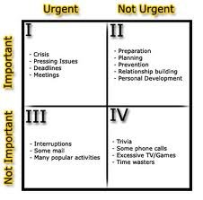This “Time Quadrant” is basically what the whole chapter is about. It has 4 main objectives in each box.
- The Procrastinator
- To put off doing something, especially out of habitual carelessness or laziness.

- The Prioritizer
- The person who arranges or deal with in order of importance.

- The Yes-Man
- a person of unquestioning obedience

- The Slacker
- One who shirks work or responsibility

